# Failure in the Field: Ethnography, Iteration, Multispecies/EcologicalRelationality and Grief

### Larissa Hjorth

I fail all the time.

Methodologically.

Epistemologically.

Research translation.

Research creation.

Multispecies relationality.

And each failure I mourn.

Waves of grief.

I sit with them.

I listen to them.

I learn from them.

## Prologue

In this chapter, I explore some of my various ethnographic failures. As I explore the limits of ethnography, I also examine how failure and grief are interwoven. Rather than ignoring failure and grief, I argue we need rituals to acknowledge the failure, to sit with it for all its awkwardness, and to grieve it. I am interested in grief as a quotidian practice that can help us connect, listen, and learn. From failure and grief we can heighten our awareness, curiosity, and reflexivity to possibilities and uncertainties. Rather than grief and failure being individuated and thus neoliberal, I argue that both are practices that are embedded in our relationalities, kinning, and being in the world. Let’s begin the meander. In homes. With animals. In climate disaster.

## Enter the Messy Field: Failure as Iteration

Like many homes around the world, the Madisons’ household in Adelaide (Australia) is playful in many ways. Some areas of the household are hubs for social activity and media use, while other spaces are quieter and more contemplative. The emotional fabric of the household follows certain rhythms of play across the spatial organization of the lounge room, computer room, and bedrooms. In the communal space of the lounge room, the play texture becomes more complex. A range of devices and play practices can be found. This assemblage includes game consoles (Wii and PlayStation), two iPads on the lounge, and three iPhones. In the evenings when the parents and their daughter are home, the lounge becomes the focus for interaction and engagement — a highly social space for shared conversation, games, and creative play. This play sometimes includes the Madisons’ cat, Bonnie, who is known to be fond of the iPad game *Cat Fishing* (Figure 19.1).As is the case in many homes, playful domestic practices often include family pets. Pets, companion animals, or what Anne Galloway calls our ‘more-than-human’ companions play an essential role in many humans’ kinship.[1]

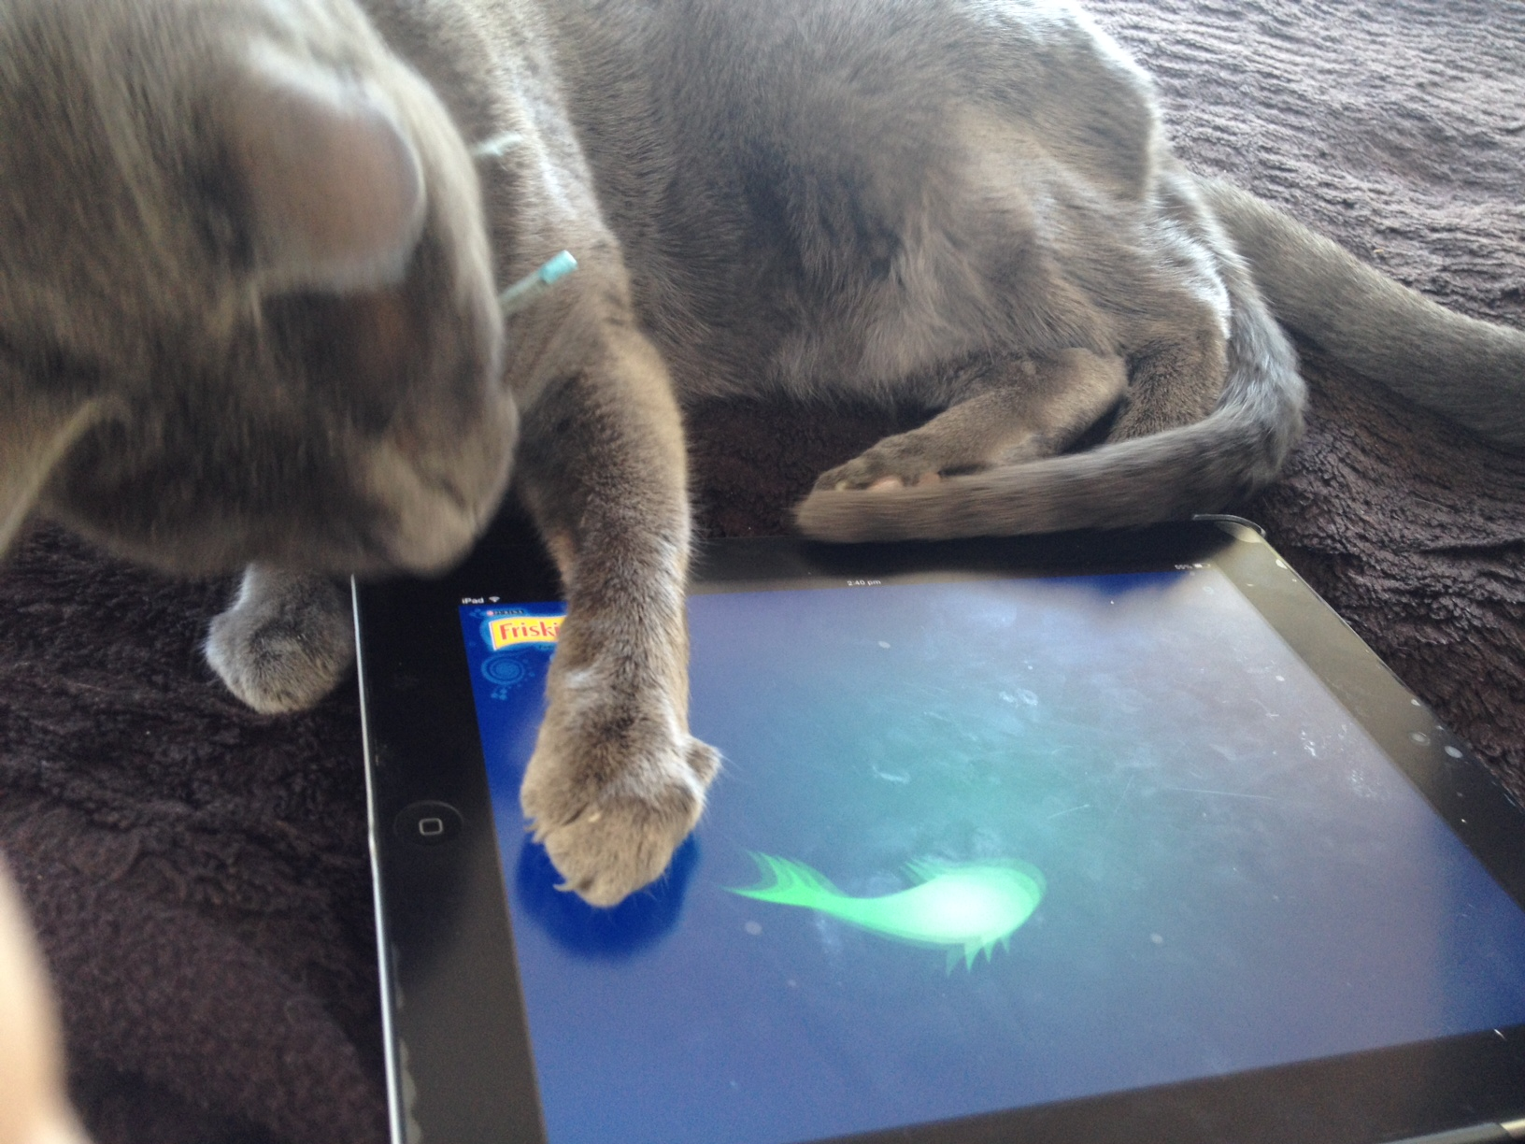

Figure 19.1: Bonnie plays with the iPad game *Friskers,* 2015. Photo: Larissa Hjorth.

The Madison household contains many stories of intergenerational and multispecies play and playfulness. In the domestic environment, this infusion of playfulness throughout the emotional and material space of the home might be described as a kind of ambient play.[2] Ambient play is the dynamics and relationality of media, human, and more-than-humans as they move in and out of the background to the foreground and back again. When I began my collaborative ethnographic research, I thought I was studying the relationship between intergenerational humans and media in households. However, as we began to enter people’s homes and talk to our participants, animals started to get in the way.

Cats siting on laptops in protest.

Dogs Skyping.

Cats playing games on the iPads.

The list went on.

The human participants constantly spoke and engaged with their more-than-humans. Before long, we realized that we had underestimated the more-than-human counterparts in our domestic environments. In Australia, two thirds of households have pets that the humans define as crucial family members.[3] One third of Australians prefer animals to humans.[4] We had failed. This was not digital ethnography. This field demanded multispecies ethnography. And more.

Our research question and methods failed.

We needed to revise it all.

Pivot.

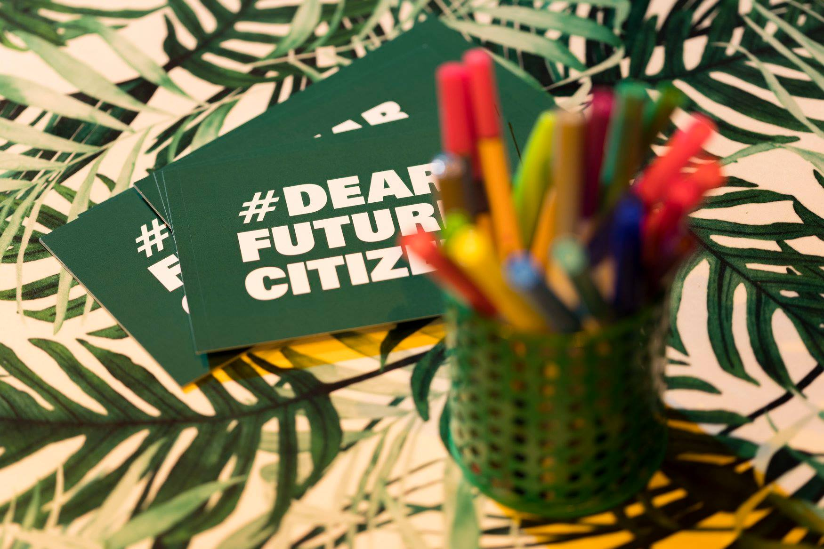

Figure 19.2: #dearfuturecitizen: Cultural prompts into perceptions of data of the dead/ death data literacy, 2018. Photo: Larissa Hjorth.

## Ethnography and Failure

Being an ethnographer is always about failure. Stories of failure shape the ethnographer’s ability to iterate — demanding them to listen and being reflexive. Iteration has become a key tool and framework for many creative disciplines to actively engage with failure in critical and productive ways.[5] It’s about the failure of the research question to stand still in the movement of the field. It’s about the failure of methods that need to be reworked in and through the field.

Behind every ethnography is a story of how the researcher thought they were going to study something in the field, but then the field became something else (or was something else from the beginning?). It’s about playing with endless uncertainty; trying to remain true to the field — its people, its more-than-humans, its stories, its ways of being. It is this failure that is crucial to doing ethnography. It involves a deep listening and reflexivity that means we, as ethnographers, are contingent to the field. As I will suggest, multispecies ethnography can help us to acknowledge failure as it moves in and through life, death, and afterlife continuities, resetting our attunement to relationality.

For James Clifford, ethnography — anthropology’s methodological approach — has always been interested in ‘invention’ not ‘representation’.[6] This interventive, creative, and non-representative role of ethnography is taken up by Philip Vannini in his ‘animating lifeworlds’, in which he argues ‘(n)on-representational theoretical ideas have influenced the way ethnographers tackle important methodological and conceptual undercurrents in their work, such as vitality, performativity, corporeality, sensuality, and mobility’.[7] This is ethnography that embraces uncertainty and risk as part of its methodological toolkit.

While my first decade of ethnographies were focused on intergenerational relationships in and through media, loss and disaster started to take my focus from 2011. Personal loss of a family member was proceeded by the Japanese Fukushima disaster in March of that year, followed by a series of natural disasters such as floods and fires. The world, as a field, was telling me something. I had failed to listen. I had got sidetracked on the details. I had to listen. Listen deeply. I realized that I had been failing to listen to the various levels and textures of grief — not just personal but rather cultural, social, and ecological. If I didn’t listen and write these stories, the grief could become trauma.

Listening to failure.

Being attuned to failure.

Failure as a way to iterate in the field with the field.

Figure 19.3: #disasterintohope series: Exploring responses to climate disaster and our ability to find hope, 2020. Photo: Larissa Hjorth.

## More-Than-Human Ethnography: Human Exceptionalism Failure

Multispecies researchers have challenged scholarly traditions, moving away from ‘default’ human exceptionalism and towards more complex relational processes. More-than-human relations have been the ongoing focus of a number of multispecies and animal studies scholars including Donna Haraway[8], Anna Tsing[9], Anne Galloway[10], Thom van Dooren[11], Eduardo Kohn[12], Rebekah Fox and Nancy Gee[13], and Andrea Petitt and Brandt-off[14], among many others, who have actively challenged traditional ways of thinking about our being-in-the-world. For Haraway, the failure of science and technology in exacerbating rather than providing solutions to ecological destruction, challenges us to ‘radically rethink’ the relationship between humans and ‘nature’, and dilate our sense of affinity, responsibility, and care to encompass animals as co-evolutionary ‘kin’.[15]

Environmental humanities has long been focused on the ethical and careful ways in which we might listen to the world as a relationality between human and non-humans. Listening here is about de-centring the human as centre and central. As Anja M. Kanngieser and Zoe Todd note, Western thought has long (and problematically) separated place, thought, and relations.[16] Haudenosaunee and Anishinaabe scholar Vanessa Watts identify this as separating ‘ontology from epistemology, knowing from being, and place from story’.[17] The relationality between humans, non-humans, and land is co-constitutive and reciprocal. Such approaches can be called a ‘kincentric’ approach to environmental humanities.[18]

According to Van Horn et al., we need to radically revise the relationality between humans and more-than-humans in terms of kinship and kinning.[19] For Anna Tsing, understanding multispecies approaches requires acknowledging that ‘human nature is an interspecies relationship’.[20] As Tsing notes, adopting ‘an interspecies frame’ opens up ‘possibilities for biological as well as cultural research trajectories’.[21] Anthropology has long been interested in problematising the role of representation and the politics of speaking on behalf of others — including more-than-humans and non-humans.

Galloway’s ‘more-than-human design’ also deploys invention as a speculative proposition in which an interspecies frame is sketched through complex and intertwined ethnographies of the various actors.[22] Galloway’s interest concerns ‘how we might develop an understanding of non-human engagement’ through speculative design and a sociology of associations and expectations, so as to better comprehend ‘the productive or generative capacities of human/nonhuman relations’.[23] Galloway puts failure at the centre of her exploration — constantly iterating in hyper-reflexive ways to the various human, non-human, and more-than-human actors. Failure is not a mistake. It is about acknowledging limitations. As Galloway argues, ‘the ability to invoke, trouble and “inhabit” other worlds and worldviews is instrumental to qualitative research’s critical and creative role in knowledge-making’.[24] This troubling of knowledge-making is crucial in my ethnographies whereby I deploy creative practice and ‘research creation’ (i.e. using creative methods to engage participants and research translation to engage publics).[25]

For many humans, animals are a core part of their kinship, requiring us to rethink kinship to encompass multispecies relationality as well as other ways of being and knowing.[26] According to human-animal ethnographers Petitt and Brandt-off, understanding this relationality of the ‘multispecies triad’ can help us developed a more nuanced model of multispecies intersectionality and kinship.[27] In understanding multispecies kinship, we need to acknowledge processes of living and also dying — requiring us to recognize the complex textures of grief involved in life’s transition. We need a multispecies kinship model that allows us to witness and show the growing stories of grief, to construct a grief literacy framework that can allow productive ways to act and change our current predicament. This kinship model also needs to acknowledge other relationalities across human, non-human, living, and non-living ties. It needs to move beyond empathic failure.

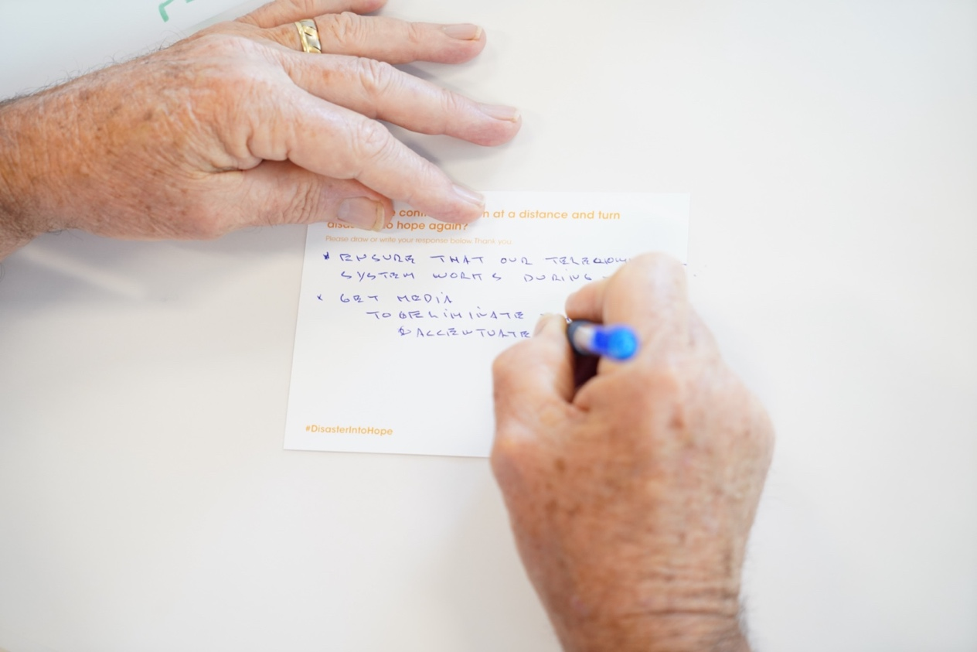

Above 19.4: #disastersintohope postcard prompts: Writing through grief to hope, 2019. Photo: Larissa Hjorth.

## Empathic Failure: Failure to Mourn in World of Increasing Disaster

Failure isn’t just related to the multispecies relationality of kinship. It is also about how we connect the land and the environment in a time of the Anthropocene (i.e. increasing catastrophic impacts of human activity on the earth’s climate and ecosystems).[28] For Richard Eckersely, the threat of the potential climate apocalypse takes three responses: nihilism, fundamentalism, and activism.[29] In an increasingly unprecedented precedent of climate disaster and pandemics, we need to attune and enhance our empathy and resilience through intersectional grief empathy and grief literacy.[30]

Grief reflects cultural hierarchies.[31] Some forms of grief are more visible than others and other forms of grief are disenfranchised/illegitimated (unacknowledged)[32] — that is, grief or loss that cannot be openly acknowledged, publicly mourned, or socially supported. Grief needs to be witnessed[33] and can take many media forms, including affective witnessing[34] — whereby media blurs distinctions between mourner and witness — and mobile witnessing — whereby the mobile device frames the experience.[35]

And yet, there are many forms of disenfranchised grief emerging — from ecological grief (eco-grief)[36] to unanticipated futures.[37] As Spain and colleagues note, this ‘occurs within a broader system of empathic failure, where social, psychological, and relational processes interact to inhibit social support’.[38] For Neimeyer and Jordan, disenfranchised grief is part of an ‘empathic failure’ across four levels: (a) self with self, (b) self with family, (c) self with community, and (d) self with transcendent reality.[39] For Doka, disenfranchised grief is loss is not socially accepted or recognized.[40] According to Doka, rituals like eulogies play a crucial role in allowing the ‘right to grieve’, which can then provide social support. If we, as Breen and colleagues argue, develop grief literacy, disenfranchised grief could become increasingly uncommon.[41]

I would like to argue that through multispecies ethnography we can glean other ways of being in the world, ones that acknowledge life, death, and afterlife continuities.[42] Many have been mourning climate change for decades — the Intergovernmental Panel on Climate Change has been releasing report after report documenting the scientific evidence that global warming of more than 1.5 degrees is ‘almost inevitable.’ And yet we have also witnessed decades of disenfranchisement by politicization and misinformation from fossil fuel lobby groups. And so our mourning went unacknowledged, turning into trauma.[43] How can we find hope through uncertainty and impeding disaster?

I would suggest creative practice offers ways to channel our grief productively. For example, in Amanda Lohrey’s *The Labyrinth,* a mother mourns her incarnated son by building a labyrinth in the sand. The impossible task — failure from the start — is about her journey to find people willing to build the impossible with her.[44] The layering of ecological grief (ecogrief) and the associated distress and melancholy — what has been called solastaglia — has become palpable in the text.[45] And yet there is a struggle to give this grief a shared vocabulary, to acknowledge it and connect.

Figure 19.5: Wait & Play cultural probe study, 2017. Photo: Larissa Hjorth.

Rather than grief being individual, as psychologists might frame it, cultural studies approaches to grief — such as Judith Butler’s work — see it as a cultural practice that reflects and reproduces a society’s norms.[46] Here, empathic failure can be seen in online vehicles like Twitter, which are overflowing with disenfranchised grief. Acknowledging grief can help us understand complex transitions in life and build resilience around tangible and more tangible forms of loss, from ecogrief (ecological grief) to the death of a loved one. Phenomena such as disenfranchised (unacknowledged) grief can lead to health issues.[47] The mental health impact of various forms of grief — such as ecogrief as a response to climate change loss — have become a key issue impacting our health services.[48] Grief around the loss of anticipated futures presented by the pandemic will continue to grow.[49] *Solastalgia.*

I want to argue for a hopeful future. I constantly codesign with others to make alternative possibilities. I workshop in and around failure as an inevitable part of becoming (see Figures 19.2-19.6).[50] I workshop cultural probes like postcards (Figure 19.5) that acknowledge failures, glitches, cracks,[51] in which play as a method, series of critical inquiries and conceptual lens takes us through empathy and risk taking. In these workshops failure is constantly palpable. Mechanisms like postcard prompts invite us to listen.

I argue for a future that acknowledges that failure is omnipresent and, like grief, needs to be sat with; listened to, for all its awkwardness, its discomfort, its sadness. By acknowledging the limits of ethnography — even multispecies and ecological approaches — to be in the world, we are constantly remaining humble to the world. And it is failure’s ability to connect us with humility that could be the success for a more caring and sustainable world.

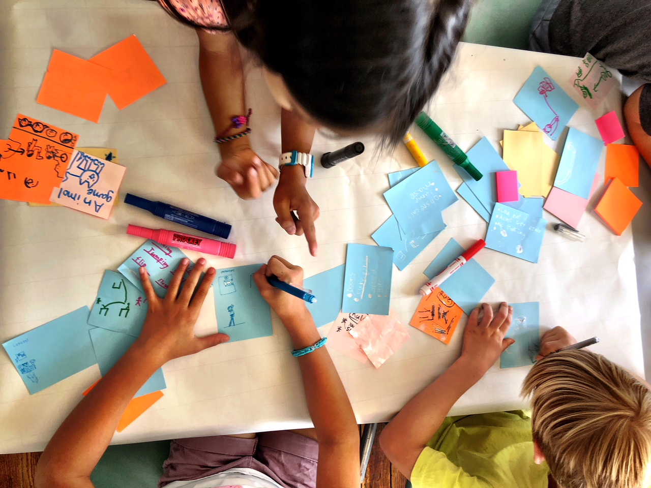

Figure 19.6: Future Play workshops: Children collaborate to create ecological games, 2017. Photo: Larissa Hjorth.

## Bibliography

Albrecht, Glenn, Sartore, Gina-Maree, Connor, Linda, Higginbotham, Nick, Freeman, Sonia, Kelly, Brian, Stain, Helen, Tonna, Anne, and Pollard, Georgia. ‘Solastalgia: The Distress Caused by Environmental Change’, *Australas Psychiatry,* 15.Suppl 1 (2007): S95-8.

Berinato, Scott. ‘That Discomfort You’re Feeling is Grief’, *Harvard Business Review,* March 23 2020, https://hbr.org/2020/03/that-discomfort-youre-feeling-is-grief

Breen, Lauren J., Kawashima, Daisuke, Joy, Karima, Cadell, Susan, Roth, David, Chow, Amy, and Macdonald, Mary Ellen. ‘Grief Literacy: A Call to Action for Compassionate Communities,’ *Death Studies*, 46:2 (2022): 425-433;

____, Aoun, Samar M., O’Connor, Moira, Johnson, Andrew R., and Howting, Denise. ‘Effect of Caregiving at End of Life on Grief, Quality of Life and General Health: A Prospective, Longitudinal, Comparative Study,’ *Palliative Medicine* 34 (2020): 145-154.

Butler, Judith. ‘Violence, Mourning, Politics’, *Studies in Gender and Sexuality*, 4:1 (2003): 9-37

Butler, Judith. *Frames of War: When Is Life Grievable?*, London: Verso, 2009.

Chapman, Owen, and Sawchuk, Kim. ‘Creation-as-Research: Critical Making in Complex Environments.’ *RACAR : Revue d'art canadienne / Canadian Art Review*, 40.1 (2015): 49—52.

Clifford, James. ‘Paradise’, *Visual Anthropology* 11.1 (1995): 92-117.

Cunsolo, Ashlee, and Ellis, Neville. ‘Ecological Grief as a Mental Health Response to Climate Change Related Loss’, *Nature Climate Change,* 8 (2018): 275-281.

Dalzell, Stephanie. ‘Do You Prefer Pets to People? So Do About a Third of Australians, According to Australia Talks’, *ABC News,* Saturday 29 May 2021, https://www.abc.net.au/news/2021-05-29/australia-talks-pets-easing-loneliness-and-bringing-people-joy/100163858.

Doka, Kenneth. ‘Disenfranchised Grief’, in Kenneth Doka (ed), *Living with grief: Loss in later life,* Washington, DC: The Hospice Foundation of America, 2002, pp. 159—168.

____. *Disenfranchised Grief: Recognising Hidden Sorrow,* Lexington, MA: Jossey Bass, 1989.

Eckersley, Richard. ‘Nihilism, Fundamentalism, or Activism: Three Responses to Fears of the Apocalypse’, *The Futurist*, 42.1 (2008): 35-39.

Fox, Rebekah, and Gee, Nancy. ‘Changing Conceptions of Care: The Humanization of the Companion Animal Relationship,’ *Society and Animals*, 24.2 (2016): 107-128.

Galloway, Anne. ‘More-Than-Human Lab: Critical and Ethnographic Experiments After Human Exceptionalism’, in Larissa Hjorth, Heather Horst, Anne Galloway, Genevieve Bell (eds), *The Routledge Companion to Digital Ethnography,* London*:* Routledge, 2017, pp. 470-477.

­­­­­_____. ‘Emergent Media Technologies, Speculation, Expectation and Human/Nonhuman Relations’, *Journal of Broadcasting and Electronic Media,* 57.1 (2013): 53-65.

Gaver, Bill, Dunne, Anthony, and Pacenti, Elena. ‘Cultural Probes’, *Interactions* 6.1 (1999): 21-29.

Haraway, Donna. *Staying With the Trouble: Making Kin in the Chthulucene*, Durham: Duke University Press, 2016.

____. *When Species Meet*, Minneapolis: University of Minnesota Press, 2008.

____. *The Companion Species Manifesto: Dogs, People and Significant Otherness*, Chicago: Chicago UP, 2003.

Hjorth, Larissa and Richardson, Ingrid. *Ambient Play*, Cambridge: MIT Press, 2020.

Kanngieser, Anja, and Todd, Zoe. ‘From Environmental Case Study to Environmental Kin Study. *History and Theory*, 59.3 (2020): 385-393.

Keightley, Emily, and Reading, Anna. ‘Mediated Mobilities’, *Media, Culture & Society* 36.3(2014): 285—301.

Klass, Dennis, Silverman, Phyllis, and Nickman, Steven. *Continuing Bonds: New Understandings of Grief,* London & New York: Routledge, 1996.

Kohn, Eduardo. *How Forests Think: Toward An Anthropology Beyond The Human,* Berkeley: University of California Press, 2013.

Lohrey, Amanda. *The Labyrinth*, Melbourne: Text Publishing, 2020.

Neimeyer, Robert, and Jordan, John. ‘Disenfranchisement As Empathic Failure: Grief Therapy and The Coconstruction of Meaning’, in K. J. Doka (ed). *Disenfranchised Grief: New Directions, Challenges, and Strategies For Practice,* Champaign, IL: Research Press, 2002, pp. 95—117.

Newby, Jonica. *Beyond Climate Grief,* Sydney: NewSouth Publishing, 2021.

Papailias, Penelope. ‘Witnessing in the Age of the Database: Viral Memorials, Affective Publics, and the Assemblage of Mourning’, *Memory Studies*, 9.4 (2016): 437—454.

Petitt, Andrea, and Brandt-off, Keri. ‘Zoocialization: Learning Together, BecomingTogether in a Multispecies Triad,’ *Society & Animals* (2022):1-18.

Reading, Anna. ‘Mobile Witnessing: Ethics and the Camera Phone in the War on Terror’, *Globalizations*, 6.1 (2009): 61—76.

Reo, Nicholas J. ‘Inawendiwin and Relational Accountability in Anishnaabeg Studies: The Crux of the Biscuit,’ *Journal of Ethnobiolog*y 39.1 (2019): 66.

Richardson, Michael, and Schankweiler, Kerstin. ‘Affective Witnessing’, in Jan Slaby J and Christian von Scheve (eds), *Affective societies: Key concepts*, New York: Routledge, 2019.

Salmón, Enrique. ‘Kincentric Ecology: Indigenous Perceptions of the Human-Nature Relationship,’ *Ecological Applications* 10.5 (2000): 1327-1332.

Sharp, John, and Macklin*,* Colleen. *Iterate: Ten Lessons in Design and Failure*, Cambridge: MIT Press, 2019*.*

Spain, Breanna, O’Dwyer, Lisel, and Moston, Stephen. ‘Pet Loss: Understanding Disenfranchised Grief, Memorial Use, and Posttraumatic Growth’, *Anthrozoös*, 32.4 (2019): 555-568.

Tsing, Anna. ‘Unruly Edges: Mushrooms as Companion Species’. *Environmental Humanities,* 1.1 (2012): 141-154.

Van Dooren, Thom. ‘Care: Living Lexicon for the Environmental Humanities’, *Environmental Humanities* 5 (2014): 291—294.

Van Horn, Gavin, Kimmerer, Robin Wall, Hausdoerffer, John (eds). *Kinship,* Canada: Centre for Humans and Animals, 2021.

Vannini, Philip. ‘Non-Representational Ethnography: New Ways of Animating Lifeworlds’, *Cultural geographies.* 22.2 (2015): 317—327.

Watts, Vanessa. ‘Indigenous Place-Thought and Agency amongst Humans and Non-Humans (First Woman and Sky Woman Go on a European World Tour!)’, *Decolonization: Indigeneity, Education & Society* 2.1 (2013).

1. Anne Galloway, ‘More-Than-Human Lab: Critical and Ethnographic Experiments After Human Exceptionalism’, in Larissa Hjorth, Heather Horst, Anne Galloway, Genevieve Bell (eds), *The Routledge Companion to Digital Ethnography,* London*:* Routledge, 2017, pp. 470-477.
2. Larissa Hjorth and Ingrid Richardson, *Ambient Play*, Cambridge: MIT Press, 2020.
3. Stephanie Dalzell, ‘Do You Prefer Pets to People? So Do About a Third of Australians, According to Australia Talks’, *ABC News,* Saturday 29 May 2021, <https://www.abc.net.au/news/2021-05-29/australia-talks-pets-easing-loneliness-and-bringing-people-joy/100163858>
4. Dalzell, ‘Do You Prefer Pets to People?’.
5. John Sharp and Colleen Macklin*, Iterate: Ten Lessons in Design and Failure*, Cambridge: MIT Press, 2019*.*
6. James Clifford, ‘Paradise’, *Visual Anthropology* 11.1 (1995): 92-117.
7. Philip Vannini, ‘Non-Representational Ethnography: New Ways of Animating Lifeworlds’, *Cultural geographies.* 22.2 (2015): 317—327, 317
8. Donna Haraway, *The Companion Species Manifesto: Dogs, People and Significant Otherness*, Chicago: Chicago UP, 2003; Donna Haraway, *When Species Meet*, Minneapolis: University of Minnesota Press, 2008; Donna Haraway, *Staying with the Trouble: Making Kin in the Chthulucene,* Durham:Duke University Press, 2016.
9. Anna Tsing, ‘Unruly Edges: Mushrooms as Companion Species’. *Environmental Humanities,* 1.1 (2012): 141-154.
10. Anne Galloway, ‘More-Than-Human Lab: Critical and Ethnographic Experiments After Human Exceptionalism’.
11. Thom Van Dooren, ‘Care: Living Lexicon for the Environmental Humanities’, *Environmental Humanities* 5: 291—294.
12. Eduardo Kohn, *How Forests Think: Toward An Anthropology Beyond The Human,* Berkeley: University of California Press, 2013.
13. Rebekah Fox and Nancy Gee, ‘Changing Conceptions of Care: The Humanization of the Companion Animal Relationship,’ *Society and Animals*, 24.2 (2016): 107-128.
14. Andrea Petitt and Keri Brandt-off ‘Zoocialization: Learning Together, BecomingTogether in a Multispecies Triad,’ *Society & Animals* (2022):1-18.
15. Donna Haraway, *Staying With the Trouble*.
16. Anja Kanngieser and Zoe Todd, ‘From Environmental Case Study to Environmental Kin Study. *History and Theory*, 59.3 (2020): 385-393.
17. Vanessa Watts, ‘Indigenous Place-Thought and Agency amongst Humans and Non-Humans (First Woman and Sky Woman Go on a European World Tour!)’, *Decolonization: Indigeneity, Education & Society* 2.1 (2013).
18. See Nicholas J. Reo, ‘Inawendiwin and Relational Accountability in Anishnaabeg Studies: The Crux of the Biscuit,’ *Journal of Ethnobiolog*y 39.1 (2019): 66, and Enrique Salmón, ‘Kincentric Ecology: Indigenous Perceptions of the Human-Nature Relationship,’ *Ecological Applications* 10.5 (2000): 1327-1332.
19. Gavin Van Horn, Robin Wall Kimmerer, John Hausdoerffer (eds). *Kinship,* Canada: Centre for Humans and Animals, 2021.
20. Tsing, **‘**Unruly Edges: Mushrooms as Companion Species**’**, 141.
21. Tsing, **‘**Unruly Edges: Mushrooms as Companion Species**’**, 141.
22. Galloway, ‘More-Than-Human Lab’.
23. Anne Galloway, ‘Emergent Media Technologies, Speculation, Expectation and Human/Nonhuman Relations’, *Journal of Broadcasting and Electronic Media,* 57.1 (2013): 53-65, 54.
24. Galloway, ‘Emergent Media Technologies’, 54.
25. Owen Chapman and Kim Sawchuk, ‘Creation-as-Research: Critical Making in Complex Environments.’ *RACAR : Revue d'art canadienne / Canadian Art Review*, 40.1 (2015): 49—52.
26. Van Horn, *Kinship*.
27. Petitt and Brandt-off, ‘Zoocialization’.
28. Kenneth Doka, *Disenfranchised Grief: Recognising Hidden Sorrow,* Lexington, MA: Jossey Bass, 1989; Kenneth Doka, ‘Disenfranchised Grief’, In Kenneth Doka (ed), *Living with grief: Loss in later life,* Washington, DC: The Hospice Foundation of America, 2002, pp. 159—168. Doka’s work has been further deployed to explore multispecies approaches to grief and has the potential to be framed in terms of ecogrief processes.
29. Richard Eckersley, ‘Nihilism, Fundamentalism, or Activism: Three Responses to Fears of the Apocalypse’, *The Futurist*, 42.1 (2008): 35-39.
30. Lauren Breen, Lauren J Breen, Daisuke Kawashima, Karima Joy, Susan Cadell, David Roth, Amy Chow, and Mary Ellen Macdonald, ‘Grief Literacy: A Call to Action for Compassionate Communities,’ *Death Studies*, 46:2 (2022): 425-433; Lauren Breen, Samar M Aoun, Moira O’Connor, Andrew R Johnson, Denise Howting’ ‘Effect of Caregiving at End of Life on Grief, Quality of Life and General Health: A Prospective, Longitudinal, Comparative Study,’ *Palliative Medicine* 34 (2020): 145-154.
31. Judith Butler, ‘Violence, Mourning, Politics’, *Studies in Gender and Sexuality*, 4:1 (2003): 9-37; Judith Butler, *Frames of War: When Is Life Grievable?*, London: Verso, 2009.
32. Doka, *Disenfranchised Grief.*
33. David Kessler (2020) cited in Scott Berinato ‘That Discomfort You’re Feeling is Grief’, *Harvard Business Review,* March 23 2020, <https://hbr.org/2020/03/that-discomfort-youre-feeling-is-grief>
34. Michael Richardson and Kerstin Schankweiler, ‘Affective Witnessing’, in Jan Slaby J and Christian von Scheve (eds), *Affective societies: Key concepts*, New York: Routledge, 2019; Penelope Papailias, ‘Witnessing in the Age of the Database: Viral Memorials, Affective Publics, and the Assemblage of Mourning’, *Memory Studies*, 9.4 (2016): 437—454.
35. Anna Reading, ‘Mobile Witnessing: Ethics and the Camera Phone in the War on Terror’, *Globalizations*, 6.1 (2009): 61—76; Emily Keightley and Anna Reading, ‘Mediated Mobilities’, *Media, Culture & Society* 36.3(2014): 285—301.
36. Ashlee Cunsolo and Neville Ellis, ‘Ecological Grief as a Mental Health Response to Climate Change Related Loss’, *Nature Climate Change,* 8 (2018): 275-281; Thom Van Dooren, ‘Care’.
37. Kessler cited in Berinato, ‘That Discomfort you’re feeling is grief’.
38. Breanna Spain, Lisel O’Dwyer, and Stephen Moston, ‘Pet Loss: Understanding Disenfranchised Grief, Memorial Use, and Posttraumatic Growth’, *Anthrozoös*, 32.4 (2019): 555-568, 556.
39. Robert Neimeyer and John Jordan, ‘Disenfranchisement As Empathic Failure: Grief Therapy And The Coconstruction of Meaning’, in K. J. Doka (ed). *Disenfranchised Grief: New Directions, Challenges, and Strategies For Practice,* Champaign, IL: Research Press, 2002, pp. 95—117.
40. Doka, *Disenfranchised Grief.*
41. Breen et al. ‘Grief Literacy’.
42. Dennis Klass, Phyllis Silverman, and Steven Nickman, *Continuing Bonds: New Understandings of Grief,* London & New York: Routledge, 1996.
43. Jonica Newby, *Beyond Climate Grief,* Sydney: NewSouth Publishing, 2021.
44. Amanda Lohrey, *The Labyrinth*, Melbourne: Text Publishing, 2020.
45. Glenn Albrecht, Gina-Maree Sartore, Linda Connor, Nick Higginbotham, Sonia Freeman, Brian Kelly, Helen Stain, Anne Tonna, and Georgia Pollard, ‘Solastalgia: The Distress Caused by Environmental Change’, *Australas Psychiatry,* 15.Suppl 1 (2007): S95-8.
46. Judith Butler, ‘Violence, Mourning, Politics’, *Studies in Gender and Sexuality*, 4:1 (2003): 9-37; Judith Butler, *Frames of War: When Is Life Grievable?*, London: Verso, 2009.
47. Breen et al. ‘Grief Literacy’.
48. Cunsolo and Ellis, ‘Ecological Grief as a Mental Health Response to Climate Change Related Loss’.
49. Kessler cited in Scott Berinato, ‘That Discomfort You’re Feeling Is Grief’.
50. See my website for further details about workshops: www.larissahjorth.net; see www.playbouring.net
51. Here I am utilising Bill Gaver’s notion of cultural probes as a creative prompt that collects often tacit perceptions. See Bill Gaver, Anthony Dunne, and Elena Pacenti, ‘Cultural Probes’, *Interactions* 6.1 (1999): 21-29.